|  |  |  |
| --- | --- | --- |
| Arjun Mehta | K036 | B.Tech CSE (Cybersecurity) |
| 24/10/2024 |  |  |

PART B

Aim: - Write a Program to work with NodeJS and Mysql

1. Write a Program to create a Database “Employee_DB” using Nodejs Script.
2. Write a Program to create a Table “Employee” using Nodejs Script.

Table Columns

Employee_Id,Employee_Name,Employee_Address, Employee_Position and Employee_Salary

1. Write a Program to insert 7 Employee Details into a Table “Employee” using Nodej Script and Each Employee_Id should not be Null and should be Unique.
2. Write a Program to display all Employee Details from Table Employee.
3. Write a Program to Display Employee_Name, Employee_Position and Employee_Salary whos Salary is more than 10000 in ascending order.
4. Create a one more Table call Employee_Profile where columns are Employee_Id, Employee_Profile and Employee_Name.
5. Write a program to join these two table and display Employee_Name , Employee_Position ,Employee_Profile and Employee_Salary based on Employee_Id.

[Note:-Write your code using Nodejs Script]

P

COURSE: Web Programming Practical Experiment: 9

Observation and Learning: -

- Write your observation and learning

CODE:

1.

|  |
| --- |
| var mysql = require('mysql2'); var con = mysql.createConnection({ host: 'localhost', user: 'root', password: 'root', port: 3306  }); con.connect(function(err)  { if (err) throw err; console.log("Connected!"); con.query("CREATE DATABASE k055_mysql", function (err, result) { if (err) throw err; console.log("Database created");  });  }); |

P

con.query("CREATE DATABASE Employee_DB", function (err, result) { if (err) throw err; console.log("Database created");

});

});

2.

|  |
| --- |
| var mysql = require('mysql2'); var con = mysql.createConnection({ host: 'localhost', user: 'root', password: 'root', port: 3306,  database: 'k055_mysql'  }); con.connect(function(err) { if (err) throw err; console.log("Connected!");  var sql = "CREATE TABLE Employee (" +  "Employee_Id INT AUTO_INCREMENT PRIMARY KEY, " +  "Employee_Name VARCHAR(255), " +  "Employee_Address VARCHAR(255), " +  "Employee_Position VARCHAR(255), " +  "Employee_Salary INT)"; con.query(sql, function (err, result) { if (err) throw err; console.log("Table created");  });  }); |

3.

var mysql= require('mysql2'); var con = mysql.createConnection({

|  |
| --- |
| host : 'localhost', user : 'root', password : 'root', port: 3306, database : 'k055_mysql'  }); con.connect(function(err){ if (err) throw err;  }); console.log("Connected!");  var sql = "INSERT INTO EMPLOYEE (Employee_Name, Employee_Position,  Employee_Salary) VALUES " +  "('PRADEEP', 'H.R', 86000), " +  "('ASHOK', 'MANAGER', 52028), " +  "('PAVAN KUMAR', 'ASST MANAGER', 28000), " +  "('SANTHOSH', 'STORE MANAGER', 9500), " +  "('THAMAN', 'GENERAL MANAGER', 26000), " +  "('SUMIT', 'WORKER', 500), " +  "('TEJAS', 'EMPLOYEE', 2000)";;    con.query(sql, function (err) { if (err) throw err; console.log(con.query('Select * from EMPLOYEE'));  }); |

4.

|  |
| --- |
| var mysql= require('mysql2'); var con = mysql.createConnection({ host : 'localhost', user : 'root', password : 'root', port: 3306, database : 'k055_mysql'  }); con.connect(function(err){ if (err) throw err;  }); console.log("Connected!"); var sql = "select * from employee; ";  con.query(sql, function (err, result) { if (err) throw err; console.log(result);  }); |

5.

|  |
| --- |
| var mysql = require('mysql'); var con = mysql.createConnection({ host :  'localhost', user : 'root', password :  'root', port: 3308, database : 'mysql'  }); con.connect(); console.log("Connected!");    var sql = "SELECT NAME,POSITION FROM EMP"  ; con.query(sql, function (err, result) { if (err) throw err; console.log(result);  }); |

6.

|  |
| --- |
| var mysql= require('mysql2'); var con = mysql.createConnection({ host : 'localhost', user : 'root', password : 'root', port: 3306,  database : 'k055_mysql'  }); con.connect(function(err){ if (err) throw err;  });  console.log("Connected!"); var sql = "create table employee_profile("+  "Employee_Id INT AUTO_INCREMENT PRIMARY KEY,"+  "Employee_Profile VARCHAR(255),"+  "Employee_Name VARCHAR(255))";  con.query(sql, function (err, result) { if (err) throw err; |

7.

|  |
| --- |
| var mysql = require('mysql2'); var con = mysql.createConnection({ host: 'localhost', user: 'root', password: 'root', port: 3306,  database: 'k055_mysql'  }); con.connect(function(err) { if (err) throw err;  }); console.log("Connected!");  var sql = "SELECT " + "e.Employee_Id, " +  "e.Employee_Name, " +  "p.Employee_Profile " +  "FROM " +  "EMPLOYEE e " +  "LEFT JOIN " +  "Employee_Profile p ON e.Employee_Id = p.Employee_Id;";  con.query(sql, function (err, result) { if (err) throw err; console.log(result);  }); |

Answer the Questions: -

Output:

1.



2.



3.

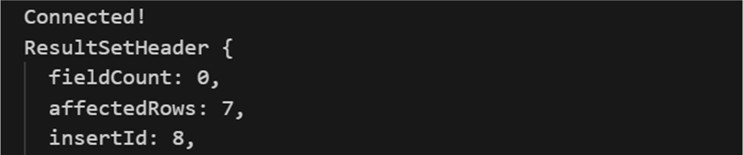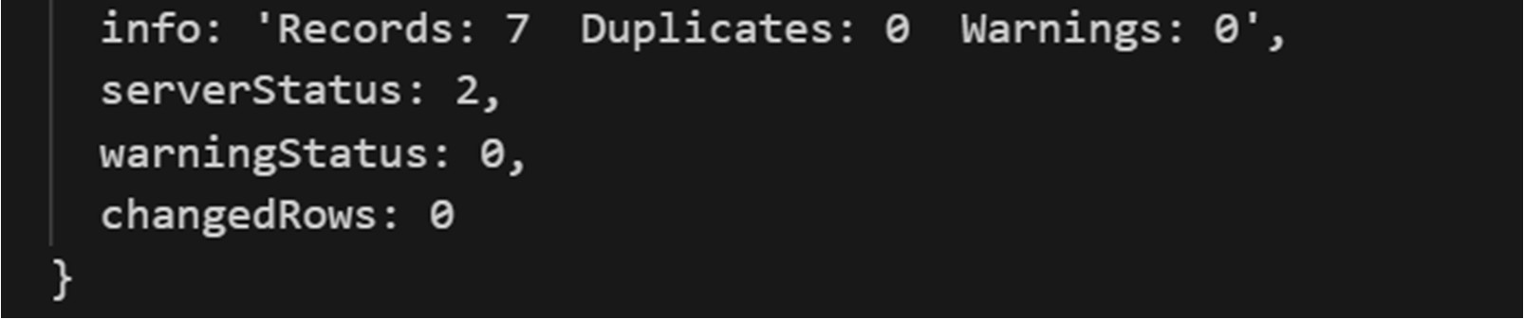

4.

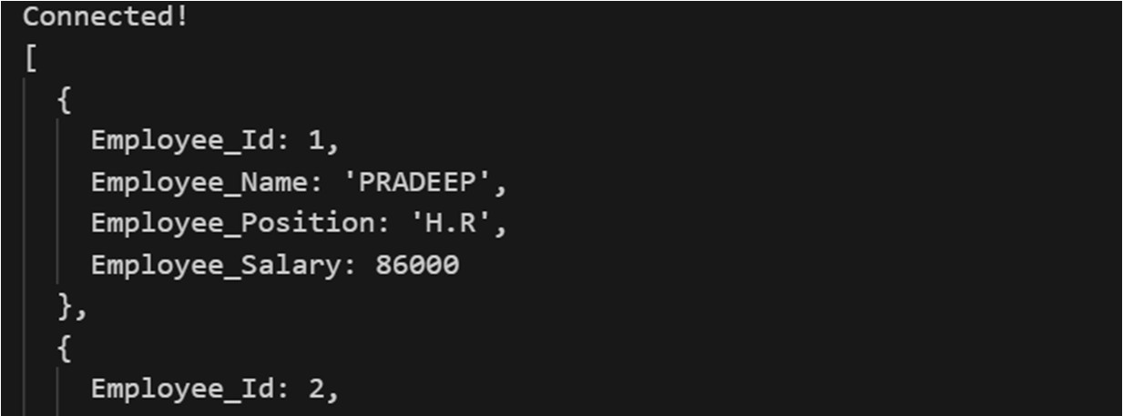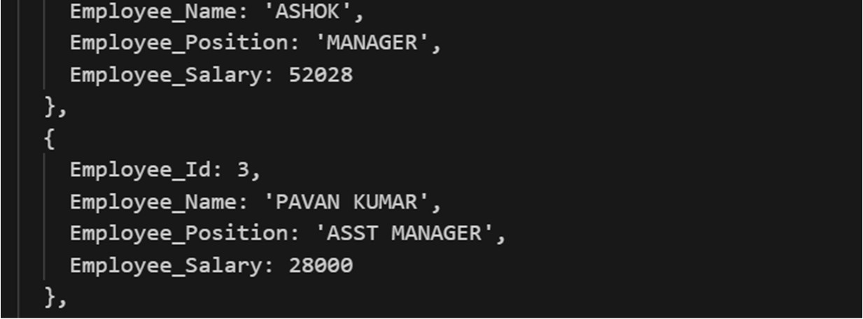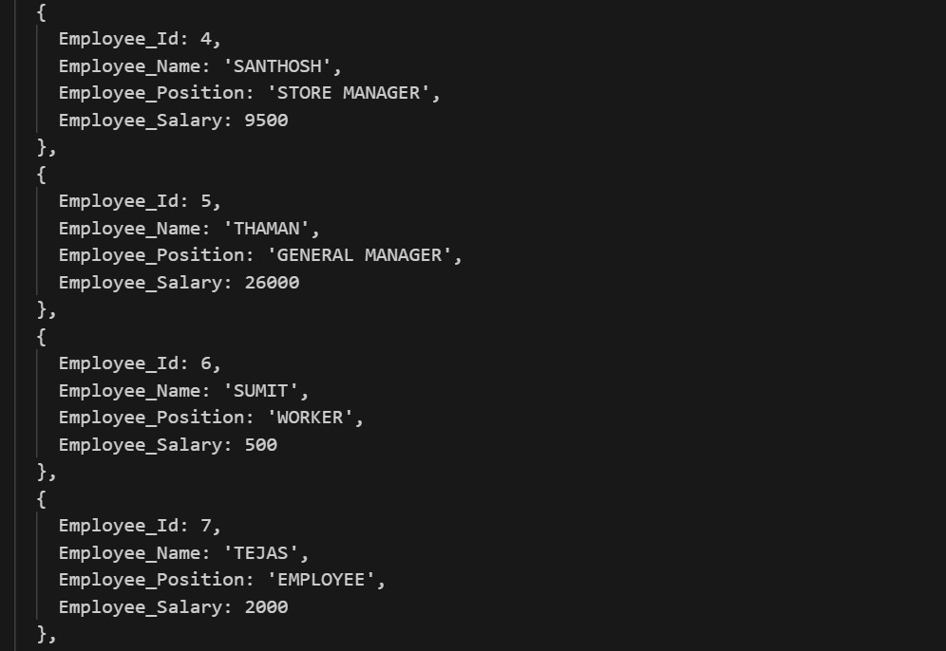

5.

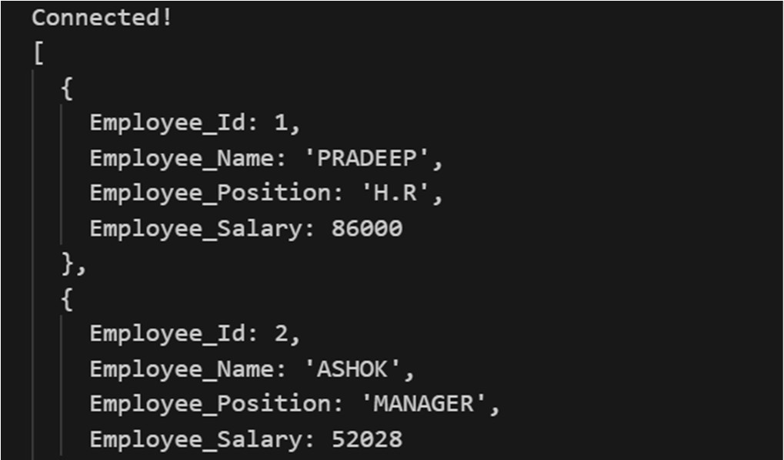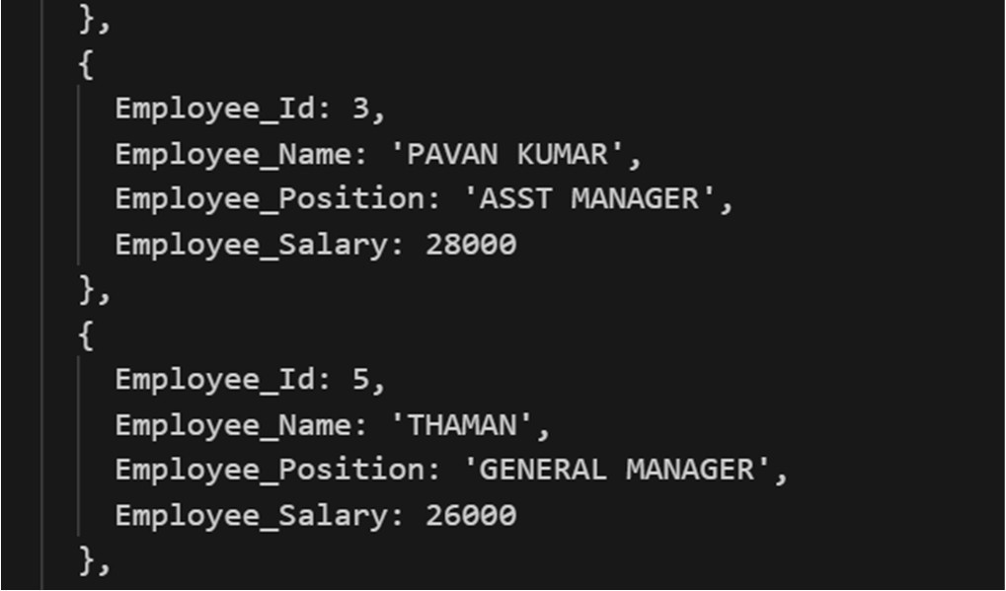

6.

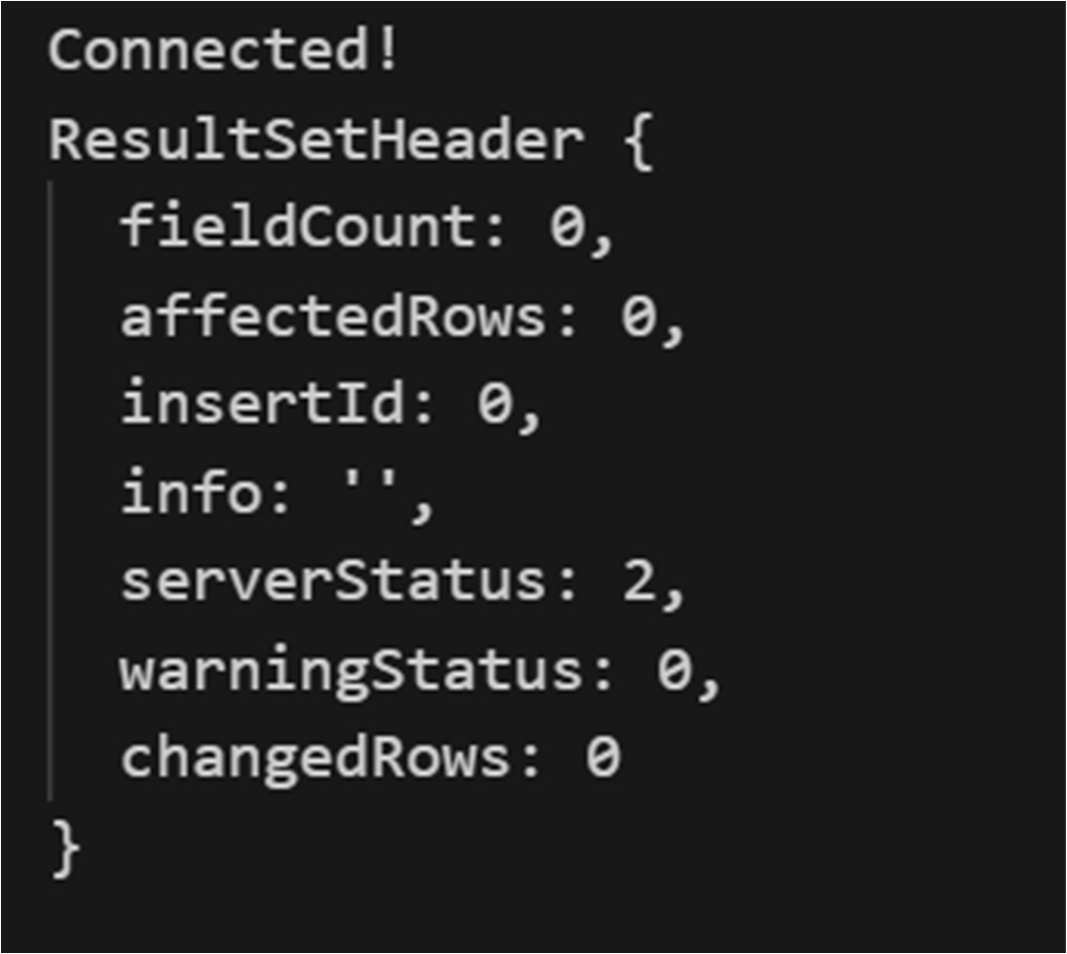

7.

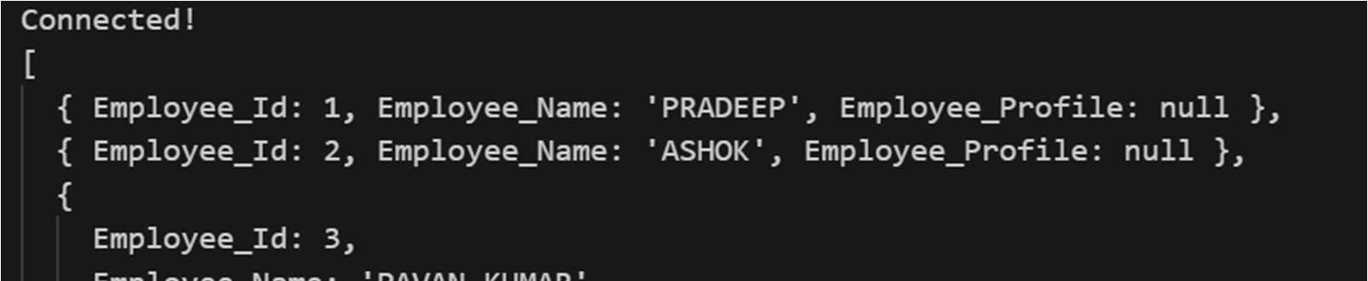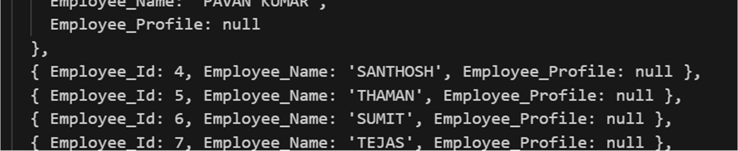

Conclusion: Have successfully learnt and implemented mysql using mysql workbench and nodejs.,